NETFUN

Lab 4: Data Throughput Lab

Equipment: Microsoft Excel

f(Hz) = frequency
A = amplitude
T = time (period)
f = 1 / T or T = 1 / f

A continuous signal containing the following components travels through different guided media.

Every number in front of a sin is the amplitude of that component e.g. amplitude of the first one is 10.5
The number in front of the pi of which gives you the frequency of that component e.g. the frequency of the first one is 50
Period is worked out via
f = 1 / T or T = 1 / f

Max period is the highest period value
Min period is the lowest period value
Bandwidth is the range of the lowest and highest frequencies
Attenuation is 10^{dB/20} (this is the amount of loss of signal we get due to the copper used in the cable) e.g. for the example below where the attenuation is -10dB we have 10^{-10dB/20} which equals 0.316227766

Each medium has a pass bandwidth, and introduces power attenuation as shown in table 1. All media have random noise levels between 2.5 and –2.5 volts. The signal components have phase distortions of /8, /4 and /2 respectively.
Power attenuation | Bandwidth
-10dB | 120Hz

Table 1

- In excel draw the frequency domain of the signal. Calculate the maximum and the minimum periods, and the bandwidth of the signal. Calculate the attenuation. Recall that the attenuation is 10^{dB/20}.

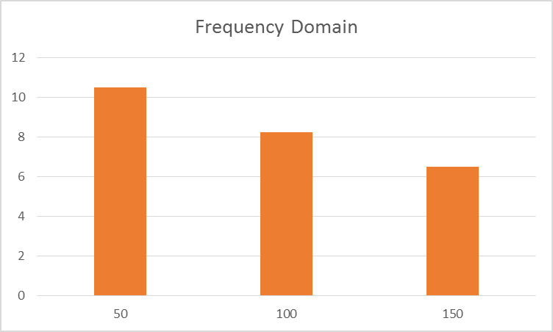
This graph shows that the higher the amplitude is the higher the frequency is as well and vis versa.

Analogue is lower quality but uses a lower frequency so can be sent further
Digital is higher quality but uses a higher frequency so can’t be sent as far

- Draw the time domain of the signal, in excel, subjected to the sources of disturbances listed in tables 1. The sheet in excel contains one column for the time, refer to steps b and c in working strategy.

- Fill the second column with the signal. Make sure you know how to enter the equation (1) in excel.
- Fill the third column with the signal in equation (1), by adding the phase delay to each component pi ()/8, pi ()/4 and pi ()/2 respectively.
- Fill the forth column with the signal affected by the bandwidth limitation. (Hint: remove the components that fall outside the bandwidth).
- Fill the fifth column by multiplying the signal with the attenuation factor calculated in part question 1.
- Fill the sixth column by adding the noise to fifth column. Refer to the step a in the working strategy.

- Can the signal be recovered at the receiver? You need to compare the final signals from each scenario. Explain what happened to the original signal? What are the distortions sources that can be compensated for to recover the signal?

Working strategy: use “Microsoft Excel” to display the signal in the time domain.

- Add to the signal a noise signal with level (2.5 to –2.5). In Excel use the expression (rand()*(b-a) + a), where b = 2.5, and a = -2.5). Ask if you are not sure.

- Maximum Period of the signal, T_{max} = 2π/100π = 0.02. Minimum Period of the signal, T_{min} = 2π/300π = 0.007. This can be divided into steps, more steps means more accuracy in the calculations. You may choose 10 steps only. Thus the incremental is .007/10 = 0.0007. When you fill the column you may stop at 0.02, which is the maximum period. So the content of your A column will be 0.0, 0.007, …, 0.02.

Hint: To draw the time column in Excel, use the expressions and time incremental. For instance A0+ incremental, click on edit, fill, down, to copy this expression to all other rows in the column A. How to calculate the incremental?

Lab Book Questions

- Can the signal be recovered at the receiver?
- Explain what happened to the original signal?

